**EXPERIMENT 7**

**Aim :**

To prepare State Diagrams for the Application Software – **Bill Management System.**

**Theory :**

**What is State Diagram ?**

A State Machine is any device that stores the status of an object at a given time and can change status or cause other actions based on the input it receives. States refer to the different combinations of information that an object can hold, not how the object behaves. Each State Diagram begins with a dark circle that indicates the initial state and ends with a bordered circle that denotes the final state. However, despite having clear start and end points, state diagrams are not necessarily the best tool for capturing an overall progression of events.

**What are the Components of State Diagram ?**

**Composite State :** A state that has substances nested into it.

**Choice Pseudo State :** A diamond symbol that indicates a dynamic condition with branched potential results.



**Event :** An instance that triggers a transition, labelled above the applicable transition arrow. For e.g., “classes end” is the event.

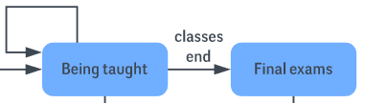

**Exit Point :** It is used if the process is not completed but has to be escaped for some error/issue.

State Diagram Symbols - Exit Point

**First State :** A marker for the first state in the process, shown by a dark circle with a transition arrow.



**Guard :** A Boolean condition that allows or stops a transition, written above the transition arrow.

**State :** A rectangle with rounded corners that indicates the current nature of an object.

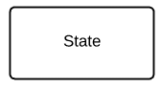

**Substance :** A state contained within a composite state’s region.

**Terminator :** A circle with a dot in it that indicates that a process is terminated.



**Transition :** An arrow running from one state to another that indicates a changing state.

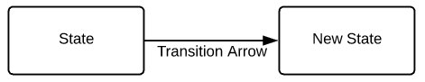

**Transitional Behaviour :** A behaviour that results when a state transitions, written above the transition arrow.

**Trigger :** A type of message that actively moves an object from state to state, written above the transition arrow. For e.g., “Issue with reservation” is the trigger that would send the person to the airport travel agency instead of the next step in the process.

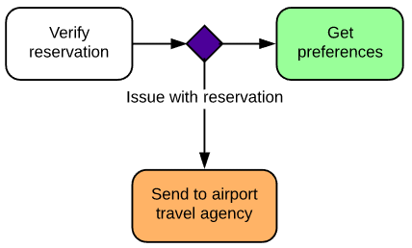

State Diagrams for the Application Software – **Bill Management System :**

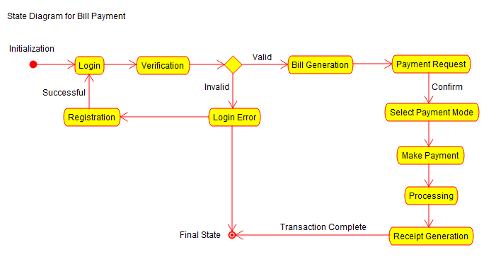

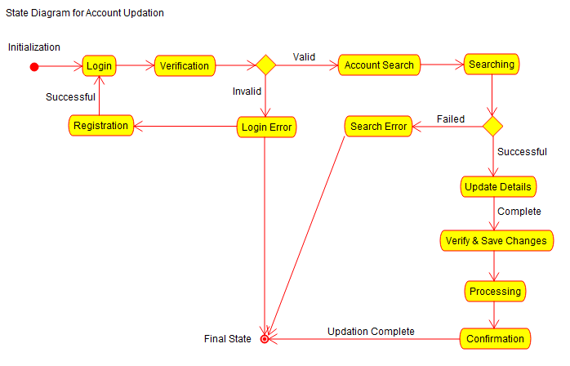

**Conclusion :**

The State Diagrams for the Application Software – **Bill Management System** were prepared successfully.